SUPERIOR TOWNSHIP
CHRISTMAS TREE Lighting
With Santa ClauS
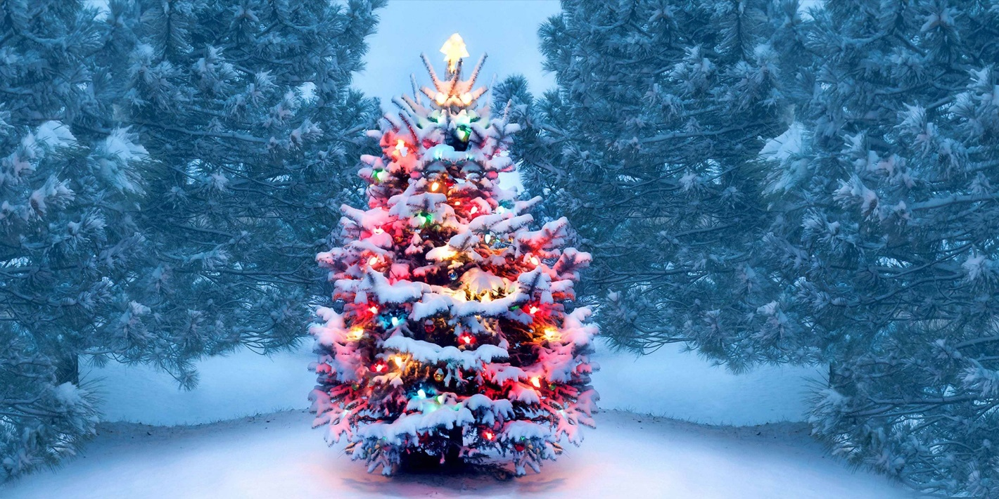


SATURDAY, DECEMBER 6th @ 6:00pM
Location:
Old Township Hall 3040 N. Prospect Rd.
Corner of Prospect & Cherry Hill
Program:
Lighting of the Superior Township
Christmas Tree, old fashioned Carolers,
Pictures w/ Santa (bring your Camera)
Ice Carving Demonstration
Warming fires
Refreshments:
Hot Chocolate & Cookies
FREE FREE FREE FREE FREE FREE FREE FREE

